**SAMIA MAZUMDER**

**CS 331**

**PROJECT #3**

CREATE TABLE ASTRO(

ASTRO_ID NUMBER (8) PRIMARY KEY ,

ASTRO_FNAME VARCHAR (25) NOT NULL,

ASTRO_LANME VARCHAR (30) NOT NULL,

ASTRO_COUNTRY VARCHAR (6) NOT NULL

);

//SAMPLE INSERT

INSERT INTO ASTRO VALUES (100, 'NEIL', 'ARMSTRON', 'USA');

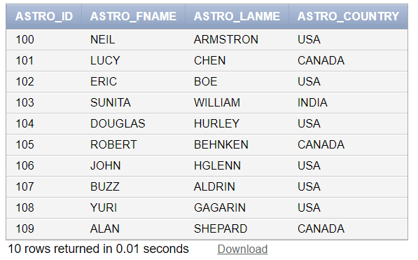

CREATE TABLE MISSION(

MISSION_ID NUMBER (8) PRIMARY KEY ,

MISSION_NAME VARCHAR (35) NOT NULL,

MISSION_SDATE DATE,

MISSION_EDATE DATE,

TARGET VARCHAR (25),

MISSION_DURATION VARCHAR (20),

MILEAGE NUMBER (20) NOT NULL

);

//INSERT SAMPLE:

INSERT INTO MISSION VALUES (202, 'JUNO', '12/17/1990', '10/12/2016', 'MARS','300 DAYS', 30000);

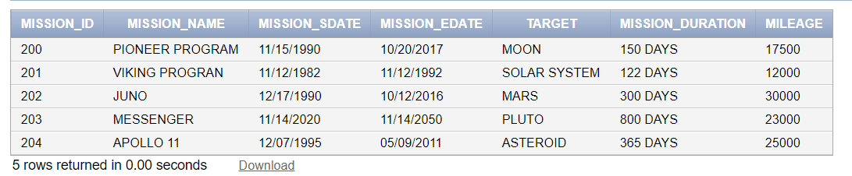

//ASTR_MISSION

CREATE TABLE ASTRO_MISSION(

ASTRO_ID NUMBER (8) NOT NULL,

MISSION_ID NUMBER (8) NOT NULL,

FOREIGN KEY (MISSION_ID) REFERENCES MISSION (MISSION_ID),

FOREIGN KEY (ASTRO_ID) REFERENCES ASTRO (ASTRO_ID)

);

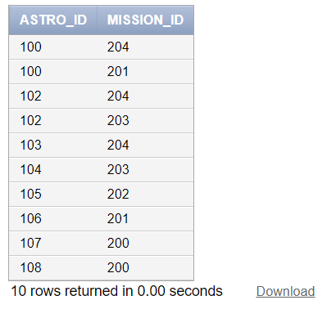

CREATE TABLE ASTRO_MAJOR(

ASTRO_ID NUMBER (8) ,

ASTRO_MAJOR VARCHAR (30) NOT NULL

);

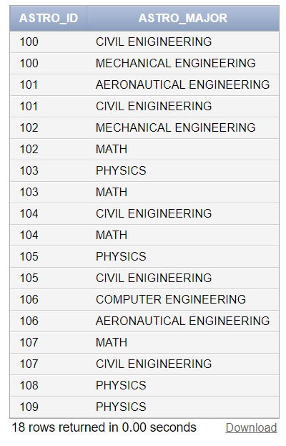

alter table "ASTRO_MAJOR" add constraint

"ASTRO_MAJOR_CON" foreign key ("ASTRO_ID") references "ASTRO" ("ASTRO_ID")

/

//SSHIP

CREATE TABLE SSHIP(

SSHIP_ID NUMBER (8) PRIMARY KEY ,

SSHIP_NAME VARCHAR (35) NOT NULL,

SSHIP_TYPE VARCHAR (35) NOT NULL

);

INSERT INTO SSHIP VALUES (300, 'STS-72A','ROBOTIC');

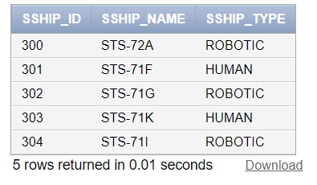

//OBJECTIVE

CREATE TABLE OBJECTIVE(

OBJ_ID NUMBER (8) PRIMARY KEY ,

OBJ_NAME VARCHAR (35) NOT NULL

);

INSERT INTO OBJECTIVE VALUES (500, 'MARS');

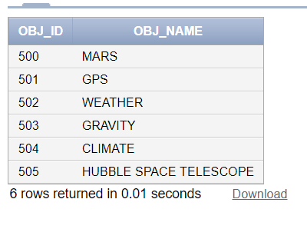

//MISSION_OBJ

CREATE TABLE MISSION_OBJ(

MISSION_ID NUMBER (8) ,

OBJ_ID NUMBER (8),

FOREIGN KEY (MISSION_ID) REFERENCES MISSION (MISSION_ID),

FOREIGN KEY (OBJ_ID) REFERENCES OBJECTIVE (OBJ_ID)

);

INSERT INTO MISSION_SSHIP VALUES (200,500);

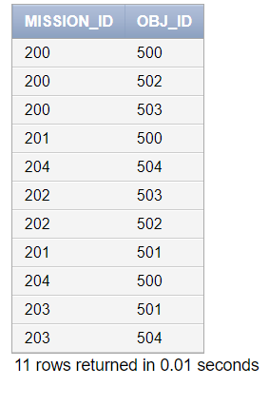

//MISSION_SSHIP

CREATE TABLE MISSION_SSHIP(

MISSION_ID NUMBER (8) ,

SSHIP_ID NUMBER (8),

SSHIP_NAME VARCHAR (35),

FOREIGN KEY (MISSION_ID) REFERENCES MISSION (MISSION_ID),

FOREIGN KEY (SSHIP_ID) REFERENCES SSHIP (SSHIP_ID)

);

INSERT INTO MISSION_SSHIP VALUES (200,300, 'STS-72A');

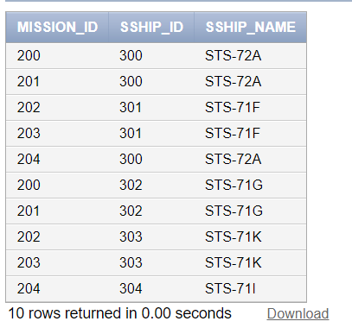

//LSITE

CREATE TABLE LSITE(

LSITE_ID NUMBER (8) PRIMARY KEY ,

LSITE_COUNTRY VARCHAR (25) NOT NULL,

LSITE_STATE VARCHAR (8) NOT NULL,

LSITE_NAME VARCHAR (40)

);

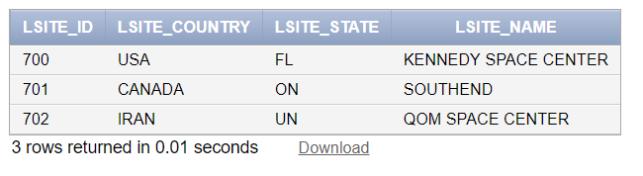

//LAUNCH

CREATE TABLE LAUNCH(

LAUNCH_ID NUMBER (8) PRIMARY KEY ,

MISSION_ID NUMBER (8) NOT NULL,

SSHIP_ID NUMBER (8) NOT NULL,

LSITE_ID NUMBER(8) NOT NULL,

LDATE DATE,

FOREIGN KEY (MISSION_ID) REFERENCES MISSION ( MISSION_ID),

FOREIGN KEY (SSHIP_ID) REFERENCES SSHIP(SSHIP_ID),

FOREIGN KEY (LSITE_ID) REFERENCES LSITE (LSITE_ID)

);

//INSERT

INSERT INTO LAUNCH VALUES( 400, 200, 300, 700, '11/15/1990');

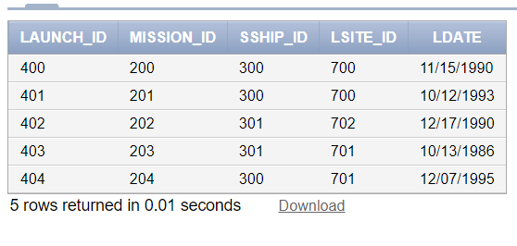

//STATUS

CREATE TABLE STATUS (

STATUS_ID NUMBER (8) PRIMARY KEY,

MISSION_ID NUMBER NOT NULL,

MSTATUS VARCHAR (25) NOT NULL,

FOREIGN KEY (MISSION_ID) REFERENCES MISSION (MISSION_ID));

INSERT INTO STATUS VALUES (600, 200,'SUCCESS');

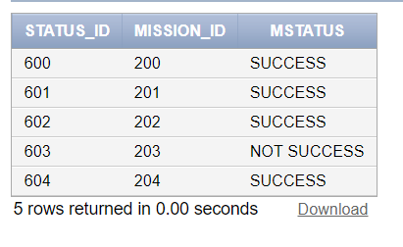

**1)Identify all Space Shuttle missions by ‘STS-72A’. Display the mission start date, end date, launch site, landing site and mission objectives.**

SELECT M.MISSION_SDATE, M.MISSION_EDATE, M.TARGET, O.OBJ_NAME, LS.LSITE_NAME

FROM MISSION M, SSHIP SS, LSITE LS, OBJECTIVE O, LAUNCH L, MISSION_OBJ MO

WHERE SS.SSHIP_NAME='STS-72A'

AND SS.SSHIP_ID= L.SSHIP_ID

AND L.MISSION_ID=M.MISSION_ID

AND L.LSITE_ID=LS.LSITE_ID

AND M.MISSION_ID=MO.MISSION_ID

AND MO.OBJ_ID=O.OBJ_ID;

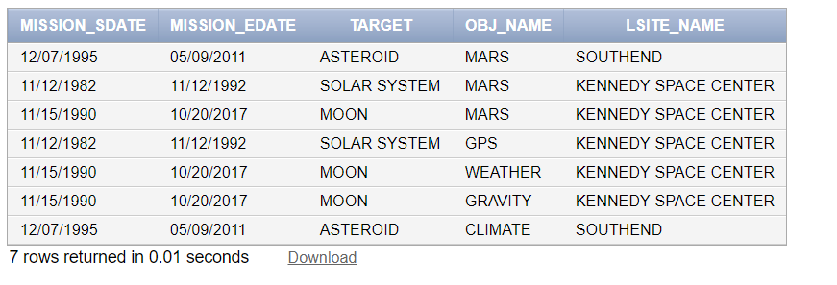

**2)Identify missions by astronaut. Display three columns: Astronaut name, number of missions and total mileage. Display one row for each astronaut. Display names in alphabetical order.**

SELECT A.ASTRO_FNAME, COUNT (M.MISSION_ID) AS "MISSIONS", SUM (M.MILEAGE) AS "TOTAL MILEAGE"

FROM ASTRO A, ASTRO_MISSION AM, MISSION M

WHERE A.ASTRO_ID=AM. ASTRO_ID

AND M.MISSION_ID= AM.MISSION_ID

GROUP BY A.ASTRO_FNAME

ORDER BY A.ASTRO_FNAME;

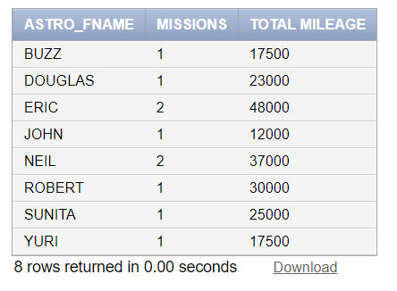

**3)Identify all missions to ‘MOON’ launched from “SOUTHEND” in the last 20 years Display the spaceship name, start and end date of mission and objectives. Order the output by date.**

SELECT S.SSHIP_NAME, M.MISSION_SDATE, M.MISSION_EDATE, O.OBJ_NAME

FROM SSHIP S, MISSION M, OBJECTIVE O, MISSION_OBJ MO, MISSION_SSHIP MS, LSITE LS, LAUNCH L

WHERE S.SSHIP_ID= MS.SSHIP_ID

AND M.MISSION_ID= MS.MISSION_ID

AND MO.MISSION_ID = M.MISSION_ID

AND O.OBJ_ID= MO.OBJ_ID

AND L.SSHIP_ID= S.SSHIP_ID

AND L.LSITE_ID= LS.LSITE_ID

AND M.TARGET= 'MARS'

AND LS.LSITE_NAME= 'SOUTHEND'

AND M.MISSION_SDATE >= '12/13/1986'

ORDER BY M.MISSION_SDATE;

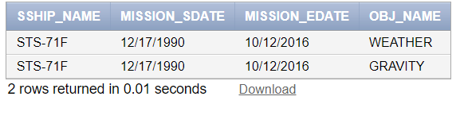

**4)Identify the missions by launch site since 2000. Display four columns: Launch site name, site country, site state and number of missions. Display one row for each launch site.**

SELECT LSITE_NAME, LSITE_COUNTRY, LSITE_STATE, COUNT(M.MISSION_ID) AS "MISSIONS"

FROM MISSION M, LAUNCH L, LSITE LS

WHERE M.MISSION_ID= L.MISSION_ID

AND L.LSITE_ID= LS.LSITE_ID

AND LDATE >='01/01/1990'

GROUP BY LS.LSITE_NAME, LS.LSITE_COUNTRY, LS.LSITE_STATE;

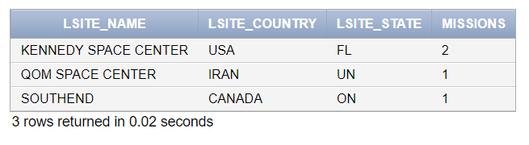

**5) Reassign astronaut Sally Ride from Space Shuttle mission STS-7 to STS-8. Identify the SQL required to implement.**

//BEFORE UPDATE:

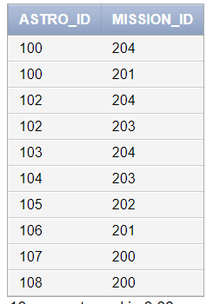

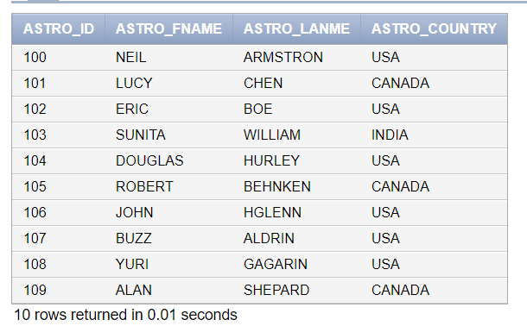

UPDATE ASTRO_MISSION

SET MISSION_ID= 201

WHERE ASTRO_ID IN (SELECT ASTRO_ID FROM ASTRO

WHERE ASTRO_FNAME= 'BUZZ' AND ASTRO_LANME= 'ALDRIN');

//AFTER UPDATE:

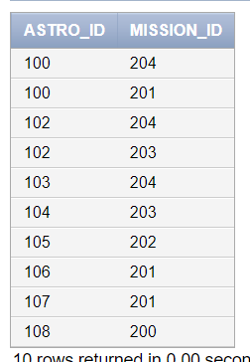

**6)Identify astronauts who have a PHYSICS degree. Use a nested select to answer this question**

SELECT ASTRO_FNAME, ASTRO_LANME

FROM ASTRO

WHERE ASTRO_ID IN (SELECT ASTRO_ID

FROM ASTRO_MAJOR

WHERE ASTRO_MAJOR ='PHYSICS')

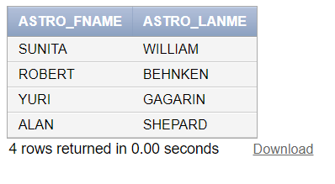

**7)Cancel Space Shuttle mission STS-71F. Identify the SQL to implement.**

//BEFORE



UPDATE STATUS

SET MSTATUS='CANCELLED'

WHERE MISSION_ID= 203;

//AFTER

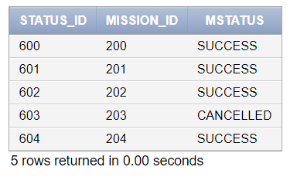

**8)Identify astronauts without missions in the last 10 years. Display the astronaut name and country. Use a nested select to answer this question.**

SELECT ASTRO_FNAME, ASTRO_LANME, ASTRO_COUNTRY

FROM ASTRO

WHERE ASTRO_ID IN (SELECT ASTRO_ID FROM ASTRO_MISSION

WHERE MISSION_ID NOT IN(SELECT MISSION_ID

FROM MISSION

WHERE MISSION_SDATE>='01/01/2008'));

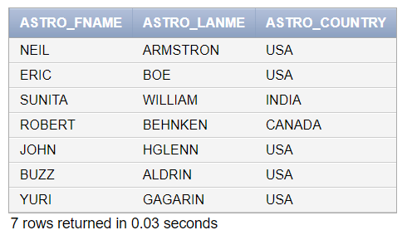

**9) In one SQL window, reassign Astronaut A to mission 1. Don’t commit. In another SQL window,. Don’t commit. Explain your results. Resolve the problem. Disable the auto commit flag at the top of the window before performing this operation**

//UPDATE*(LEFT WINDOW)* COMMANDS:

UPDATE ASTRO_MISSION

SET ASTRO_ID = 106

WHERE MISSION_ID =202;

//BUT DISABLED THE “AUTO-COMMIT” CHECKBOX.

NOW OPENED ANOTHER SQL USER SIGN IN WHICH IS *(RIGHT WINDOW)*

AND USED SAME COMMAND IN BOTH WINDOW

THE COMMAND IS :

SELECT * FROM ASTRO_MISSION;

//RESULT

AS THE WINDOW 1 THE COMMAND IS NOT COMMET OR ROLLBACK THAT WHY WINDOW 2 THE UPDATED VALUES ARE NOT SHOWING.

IF IT WAS COMMETED THEN WINDOW 2 WOULD BE ABLE TO SEE THE UPDATE VALUES.

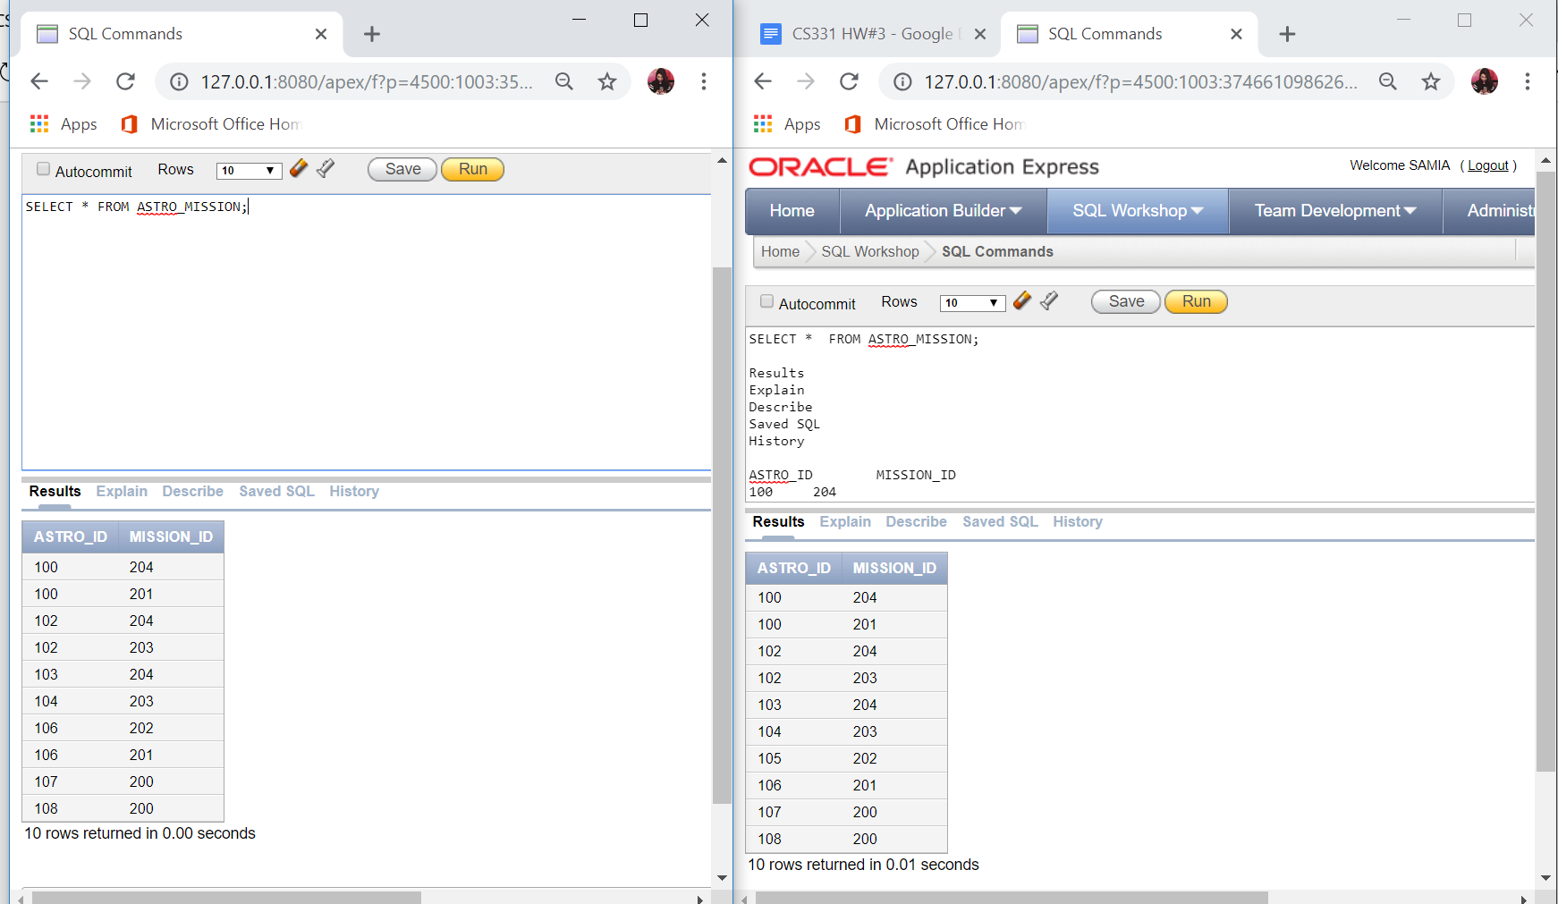

**10). In one SQL window, delete the astronaut YURI GAGARIN. Don’t commit. In another SQL window, assign astronaut Sally Ride to a new mission. Don’t commit. Explain your results. Resolve the problem. Create a backup table before implementing. To create a backup table, enter CREATE TABLE <NEWTABLE> AS SELECT * FROM <ORIGINALTABLE>; COMMIT; Then you can rename a table using the RENAME TABLE commit. Disable the auto commit flag at the top of the window before performing this operation.**

//COMMANDS (*LEFT WINDOW*):

DELETE FROM ASTRO_MISSION

WHERE ASTRO_ID= 108;

// COMMANDS*(RIGHT WINDOW*):

UPDATE ASTRO_MISSION

SET MISSION_ID= 204

WHERE ASTRO_ID= 108;

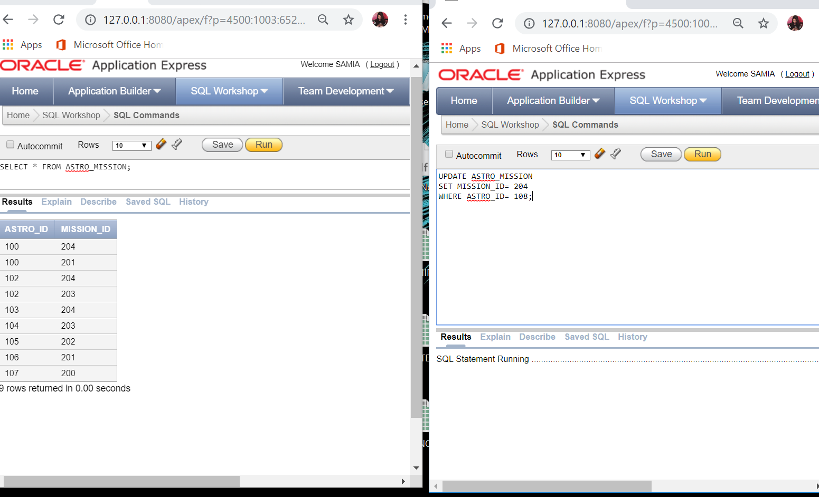

SO LEFT WINDOW I HAVE DELETED THE ASTRONAUT NAMED YURI GAGARIN AND ASTRO_ID =108 AND RIGHT WINDOW HAVE ASSIGNED SAME ASTRONAUT ASTR_ID=108 FROM MISSION _ID=200 TO MISSION_ID =204 AND ITS GIVING “SQL Statement Running…………..” MEANING THERE IS ANOTHER WINDOW OPEN AND THERE IS A LOCK IN THE TABLE WHICH IS THE HIGHEST LOCK. TO RESOLVE THIS

PROBLEM IS TO FINISH THE RUNNING SESSION ON THE ONE WINDOW TO WORK IN THE OTHER WINDOW OR BY USING COMMAND ROLLBACK OR COMMIT CAN RELEASE THE LOCK ON THE TABLE ASTR_MISSION.

**11) In one SQL window, rename the Space Shuttle STS-72A to STS-71K. Don’t commit. In another SQL window, change the Space Shuttle STS-72A to STS-71G. Don’t commit. Quit both Oracle sessions. Login to Oracle and display all information for the Space Shuttle Enterprise.** Explain your results. Disable the auto commit flag at the top of the windows before performing this operation.

*//*COMMANDS *( LEFT WINDOW)*

UPDATE SSHIP

SET SSHIP_NAME='STS-71K'

WHERE SSHIP_NAME='STS-72A';

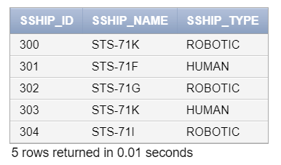

//COMMANDS *(RIGHT WINDOW)*

UPDATE SSHIP

SET SSHIP_NAME='STS-71G'

WHERE SSHIP_NAME='STS-72A';

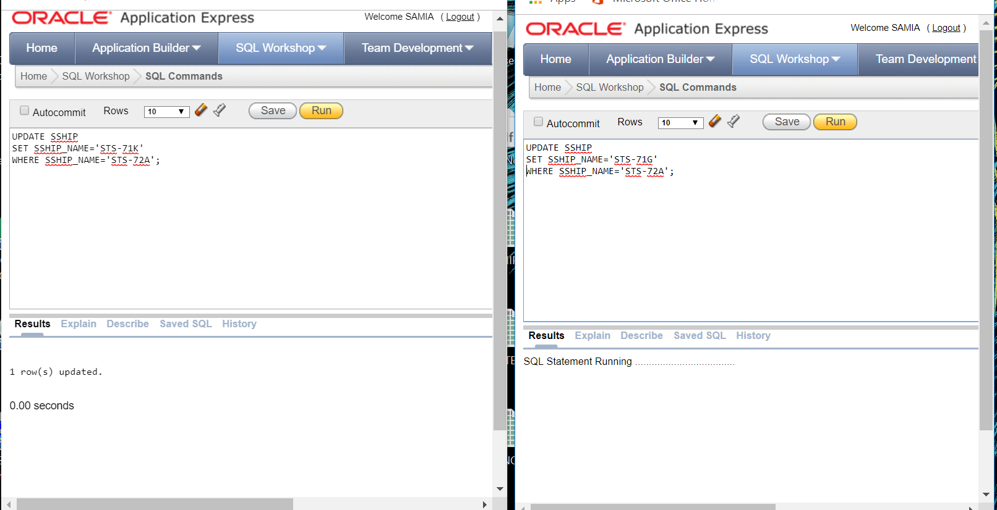

IN HERE WE CAN SEE THAT LEFT SIDE COMMAND WAS SUCCESSFULLY WORKED AND UPDATED THE ROW BUT ON THE RIGHT WINDOW IT HAS THE “SQL Statement Running……..” MESSAGE THAT THE SSHIP TABLE HAS A LOCK ON IT AND ONLY WAY TO RESOLVE IT IS TO USE COMMAND ‘COMMIT OR ROLLBACK’ OR FINISH THE SESSION THATS RUNNING IN THIS CASE THE SESSION IS RUNNING IN THE LEFT WINDOW.

//NOW AFTER QUITTING FROM BOTH WINDOW AGAIN LOGGING INTO ORACLE:

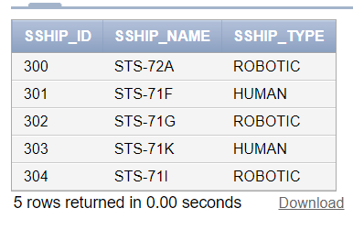

AS WE CAN SEE NOTHING HAS UPDATED AS I DIDN’T USE THE COMMIT COMMAND IN SSHIP TABLE.

**12)table desc**

**//astro**

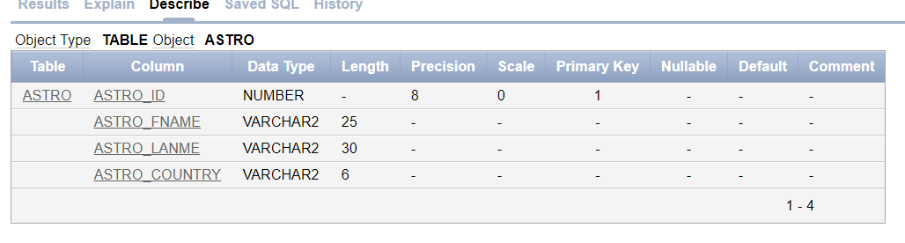

**//Mission**

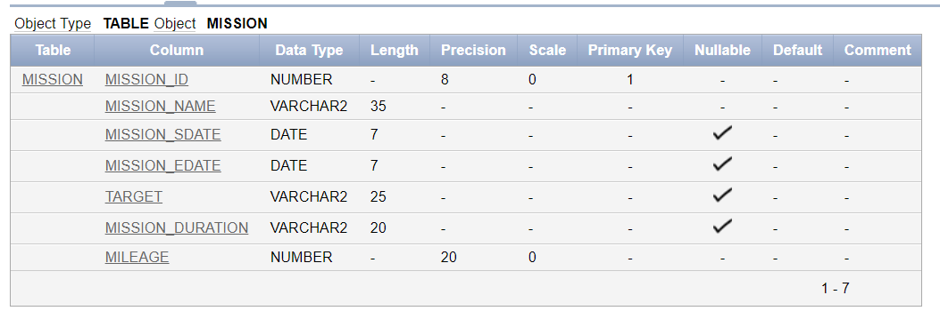

**//astro_mission**

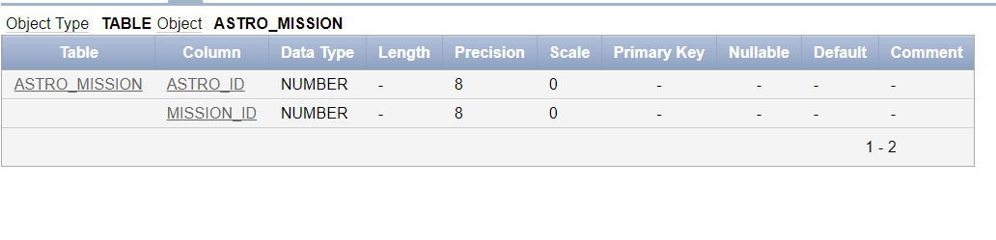

**//astro_major**

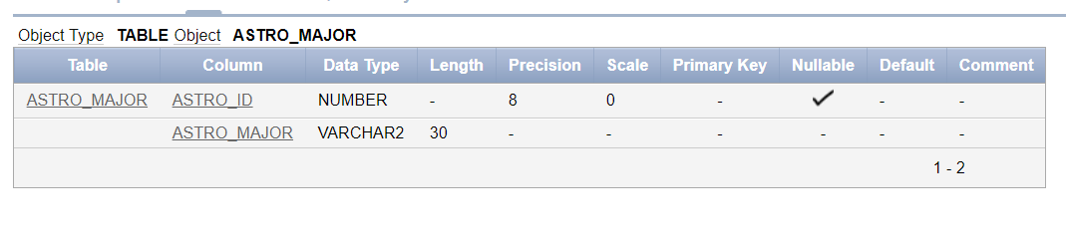

**//sship**



**//objective**

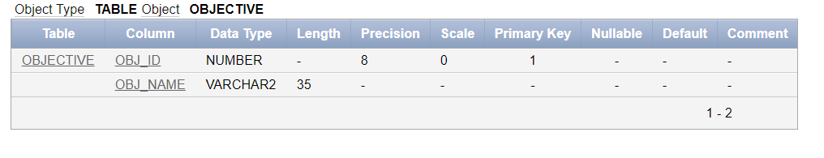

**//mission_obj**

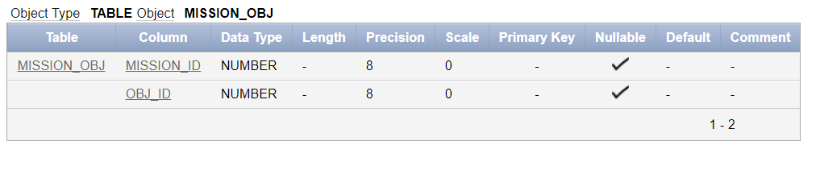

**//mission_sship**

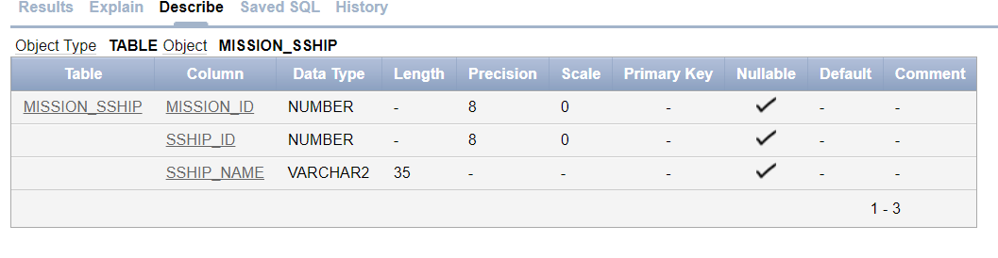

**//lsite**

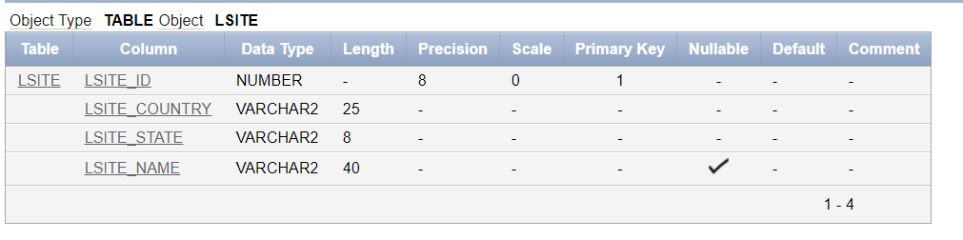

**//launch**

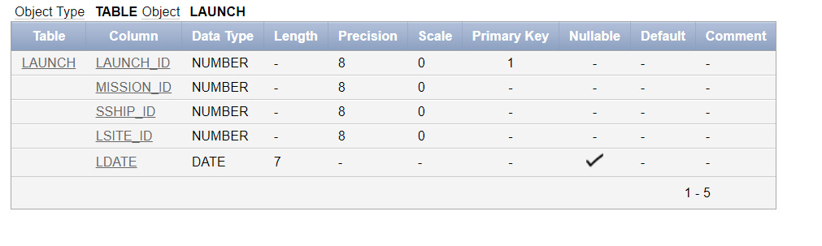

**//status**

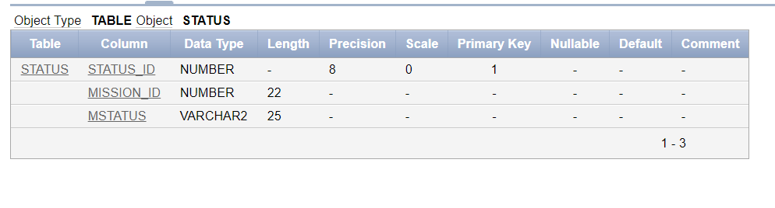

**13) Display the Oracle version by entering**

